Abstract Template for the EMSLIBS 23

A. B. Author^{1,a)}, C. D. Author¹, and E. F. Author²

¹ Use Complete Addresses for the First Group of Authors.
² Use Complete Addresses for the Second Group of Authors.

^{a)} Corresponding author: your@emailaddress.xxx

This is the abstract template file for the EMSLIBS 23 conference. Page size is A4 page borders are 2 cm wide. Title is in Calibri font 18pt size, bold, in cap/lower case, single-spaced, and centered at the head of the page. The authors are in Calibri font 14pt size, in cap/lower case, and centered. An empty line in 8pt follows the authors. The affiliation and the addresses are in Calibri font 12pt size, italic, in cap/lower case, single-spaced, and centered. Use one 12pt empty line between the corresponding author and the text body. The name of the presenter should be in bold.
The text body is in Calibri font 10pt size, in single column format, fully justified, and single-spaced. The bibliographic items are referenced as follows [1-4]. When referring to citations in the text, in square brackets [], show the number in order of appearance. Submission of the abstract should be completed according to the deadline reported on the conference website (https://emslibs2023.inesctec.pt/). The abstract should be one page long and should be uploaded according to the guidelines. The abstract will be reviewed by the scientific and organizing committee. The notification of acceptance will be sent by email at the address you include in the registration form.

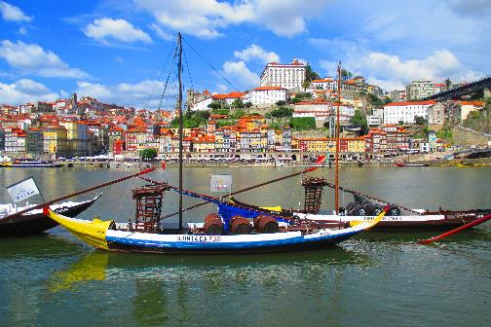
Fig. 1. The figure caption is in Calibri 10pt, bold, justified, and single-spaced.

ACKNOWLEDGEMENTS

Details of the funding agency/grant if any, must be in Calibri font 10pt size.

REFERENCES

[1] A. B. Author, C. D. Author, Journal Title, 1, pp. 37-42 (2013).
[2] A. B. Author, Book Title (Publisher, City, 2012), pp. 135-142.
[3] A. B. Author, Proc. of the ... Conference... (Publisher, City, 2014), pp. 45-52.
[4] A. B. Author, Thesis Title (Ph.D. Thesis, A University 1998).

