Title in 11 pt (two lines maximum recommended)
F. Author^{1,*}, S. Author², T. Author^{1,3}
¹ Institution, Address, Town, Country; ² Institution, Address, Town, Country; ³ Institution, Address, Town, Country; *contact_author@email_address.
The Graphical Abstract (Figure, Scheme, etc.) should not exceed the size of this area (7 cm × 7 cm). Please insert it as a Picture Enhanced Metafile. | Authors and the email address of the corresponding author should be typed as indicated above in Times New Roman 9 pt, italic. The presenting author name should be underlined. The presenting author must be registered for the CHEMPOR 2018 Meeting.  A Short Abstract (≤ 1000 characters, including spaces, Times New Roman 9 pt) indicating the main highlights of the work should be included here.

Abstracts must be submitted using the Abstract submission form on the CHEMPOR 2018 website (www.chempor2018.com) no later than August 24th, in MSWord format or any compatible file format.

The file should be named as “Surname_Initials[_#].docx”, corresponding to the Registered Author and to the number of his/her submitted abstract. For example: “Reynolds_O.docx”, “Perry_JH_1.docx” and “Perry_JH_2.docx”.

Abstracts will be considered only if the following guidelines are respected. The full abstract must be written in English, Times New Roman 9 pt, and cannot be longer than 2 pages (for both oral and poster presentations).

Abstracts should be written in such a way that the Introduction, Objectives, Methods, Results and Conclusion are briefly described. However, the use of all these headings is NOT mandatory. Headings should be Times New Roman 9 pt, bold, without numbering.

Do not use non-standard abbreviations in tables and figures captions. Leave one blank line (9 pt) before and after each figure or table. Insert figures as Picture Enhanced Metafiles.

The corresponding captions (Times New Roman 9 pt) should straight follow the figure, without any line between the figure and its caption. The Graphical Abstract can be also cited in the text (e.g., “…as shown in the Graphical Abstract.”).

Tables should be numbered and composed within one page column (e.g., Table 1). If a table requires both page columns, it should be placed at the end, just before the Acknowledgements section (e.g., Table 2).

The Acknowledgements and References should sections appear at the end of the abstract. Leave one blank line (9 pt) before the section titles.

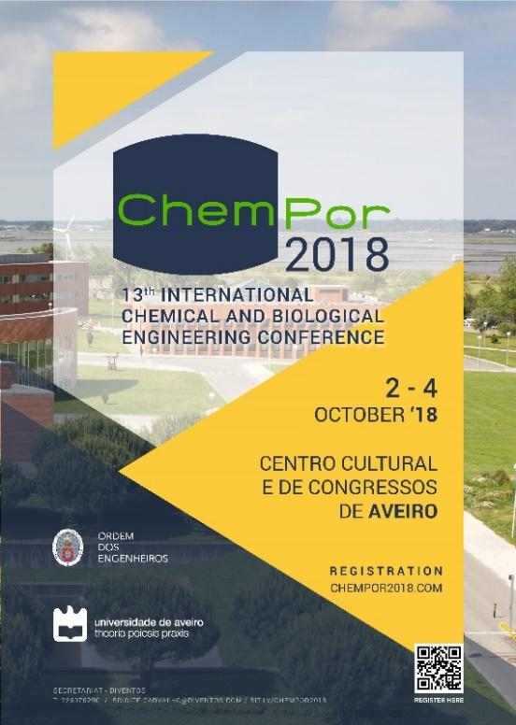
Figure 1. Caption.

References should be sequentially numbered in the text and indicated in square brackets before punctuation (e.g., “…reaction engineering [1,2].”; “…as shown by other authors [2-4],…”). Please follow the corresponding styles for articles in journals [1], conference proceedings [2], books [3] and articles in books [4]. A maximum of 10 references is recommended (not valid for plenary lectures).

Table 1. Small table.
Heading 1 | Heading 2 | Heading 3 | Heading 4
Text | Text | Text | Text
Text | Text | Text | Text

Table 2. Large table at the end, if required.
Heading 1 | Heading 2 | Heading 3 | Heading 4
Text | Text | Text | Text
Text | Text | Text | Text

Acknowledgements
The acknowledgements should be written here.

References
[1] X. Author, Y. Author, Z. Author, Journal Name, Volume (Year) Pages.
[2] X. Author, Y. Author, Z. Author, Proc. of CHEMPOR 2011 – 11th International Chemical and Biological Engineering Conference, Lisbon, Portugal, Year, Pages.
[3] X. Author, Y. Author, Z. Author, Book Title, # Ed., Publisher, City, Year, Pages.
[4] X. Author, Y. Author, Z. Author, Chapter # in Book Title, W. and H. Editors, # Ed., Publisher, City, Year, Pages.

